**PERFORMANCE REPORT**

**After running each test you have to repopulate the database .**

All the performance test has been executed in the Developer VM with the next configuration:

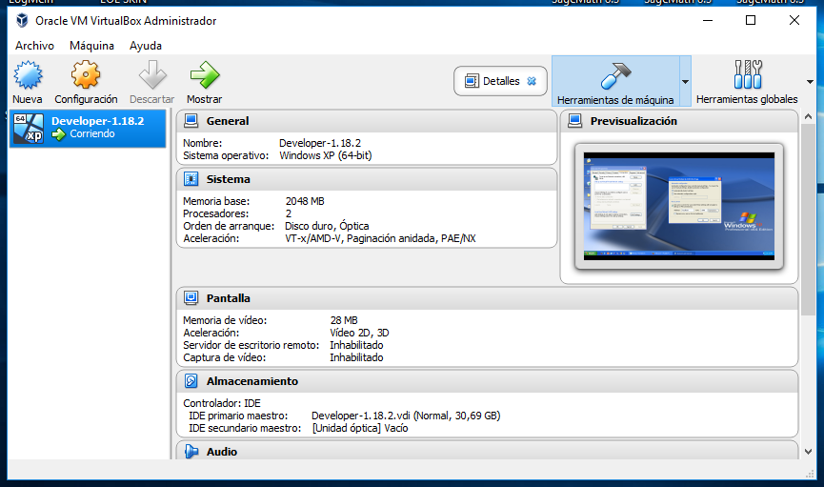

We have to set the proxy configuration as the following picture to run the test in the Developer VM:

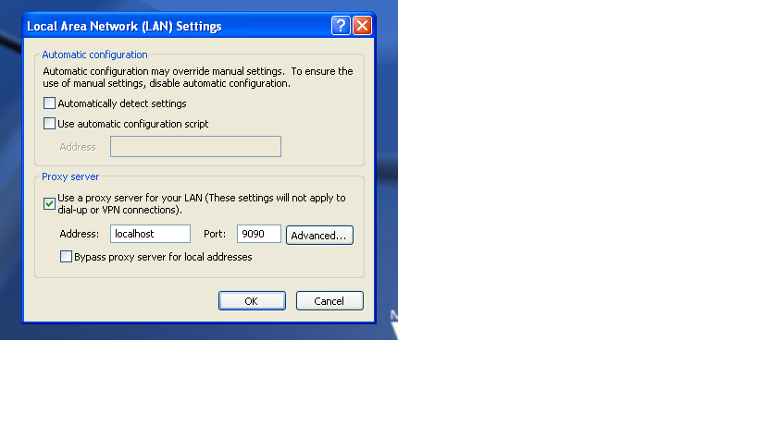

REGISTER COMPANY TEST (UC 7.1 – Acme Hacker Rank)

In this test we performance the creation of new companies in the system. The test consists of 10 threads (user) doing 10 loops, these are the results.

AGGREGATE REPORT

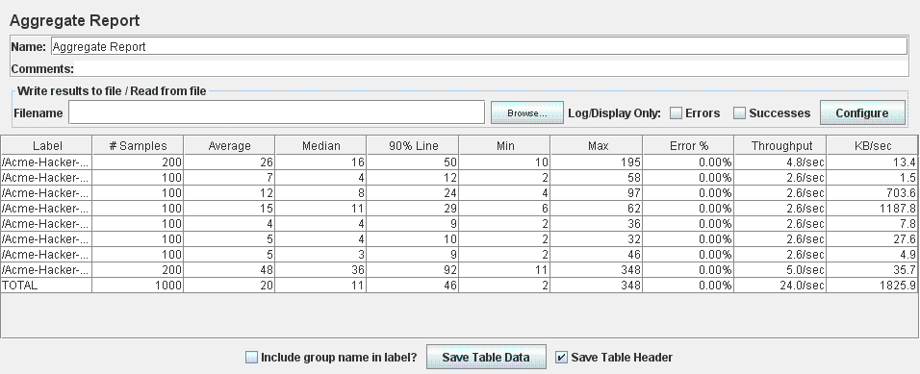

GRAPH RESULT

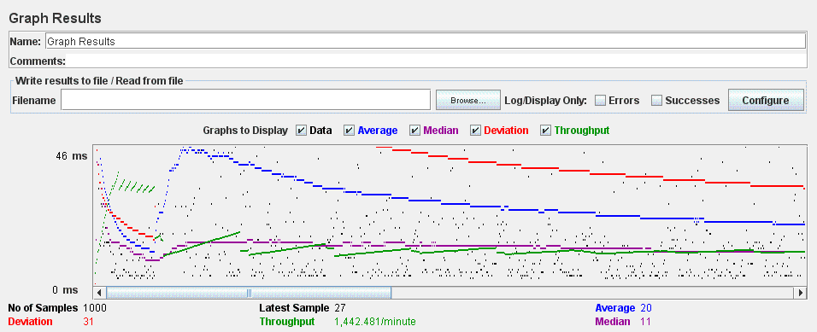

REGISTER HACKER TEST (UC 7.1 – Acme Hacker Rank)

In this test we performance the creation of new hackers in the system. The test consists of 10 threads (user) doing 10 loops, these are the results.

AGGREGATE REPORT

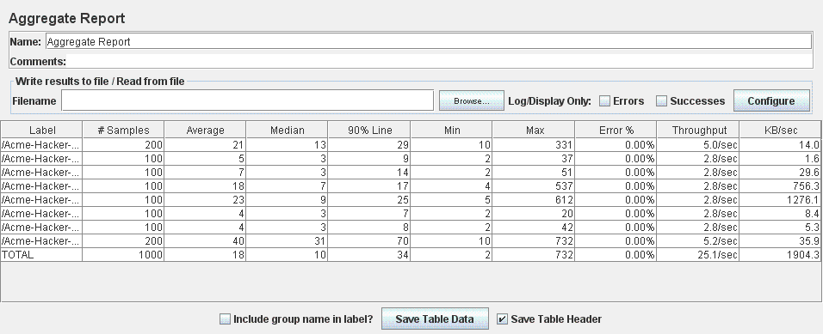

GRAPH RESULT

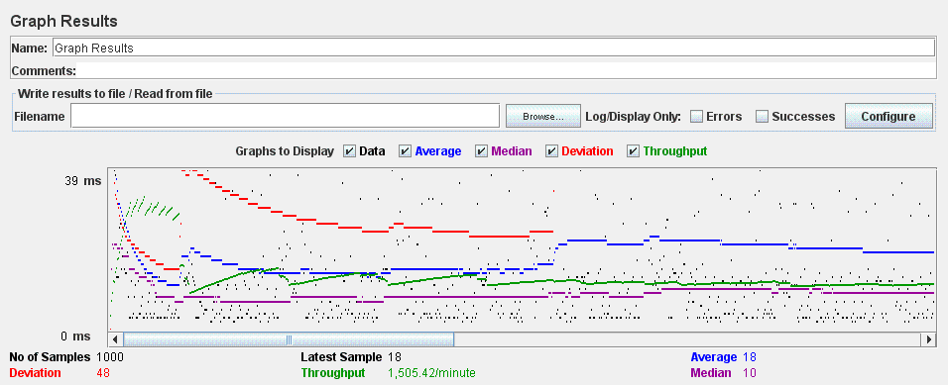

REGISTER COMPANY TEST (UC 7.1 – Acme Hacker Rank)

In this test we performance the creation of new companies in the system. The test consists of 10 threads (user) doing 10 loops, these are the results.

AGGREGATE REPORT



GRAPH RESULT



REGISTER HACKER TEST (UC 7.1 – Acme Hacker Rank)

In this test we performance the creation of new hackers in the system. The test consists of 10 threads (user) doing 10 loops, these are the results.

AGGREGATE REPORT



GRAPH RESULT



LIST NOT LOGGED POSITION TEST (UC 7.2 – Acme Hacker Rank)

In this test we performance the list of positions as a not logged actor. The test consists of 10 threads (user) doing 10 loops, these are the results.

AGGREGATE REPORT

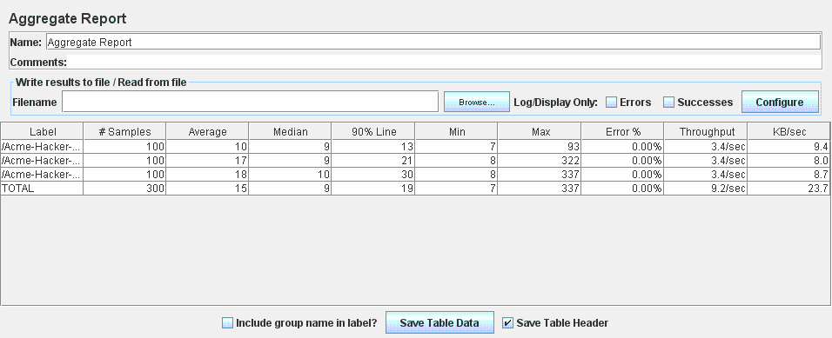

GRAPH RESULT

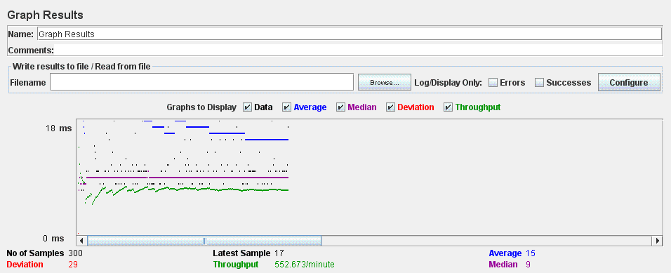

LIST COMPANIES NOT LOGGED TEST (UC 7.3 – Acme Hacker Rank)

In this test we performance the list of companies as a not logged actor. The test consists of 10 threads (user) doing 10 loops, these are the results.

AGGREGATE REPORT

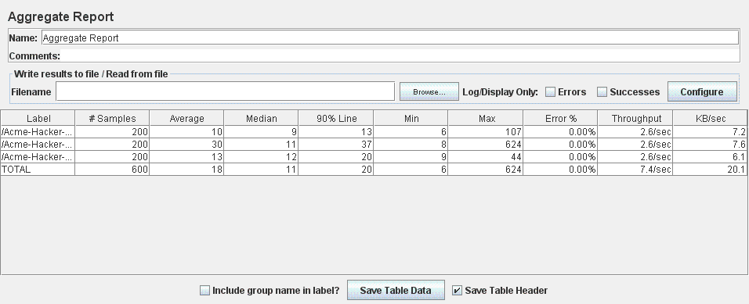

GRAPH RESULT

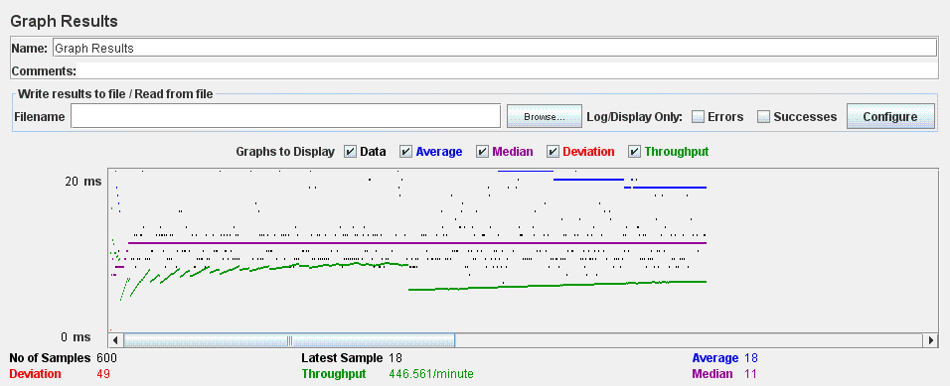

SEARCH FINDER NOT LOGGED TEST (UC 7.4 – Acme Hacker Rank)

In this test we performance the finder of positions as a not logged actor. The test consists of 10 threads (user) doing 10 loops, these are the results.

AGGREGATE REPORT

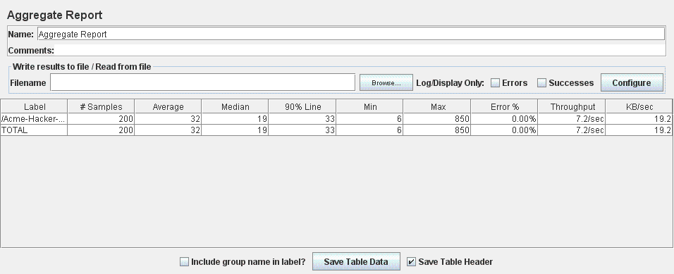

GRAPH RESULT

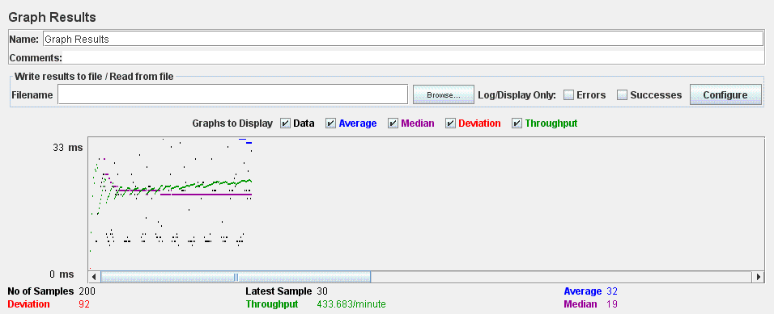

EDIT PERSONAL DATA ADMINISTRATOR TEST (UC 8.2 – Acme Hacker Rank)

In this test we performance the edition of the administrator personal data. The test consists of 10 threads (user) doing 10 loops, these are the results.

AGGREGATE REPORT

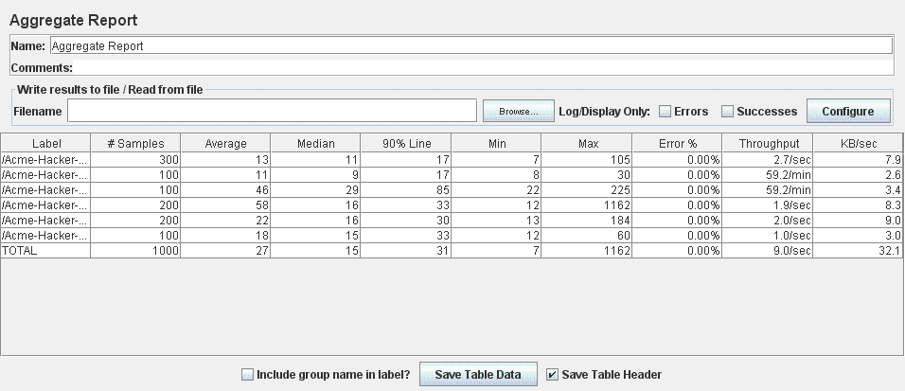

GRAPH RESULT

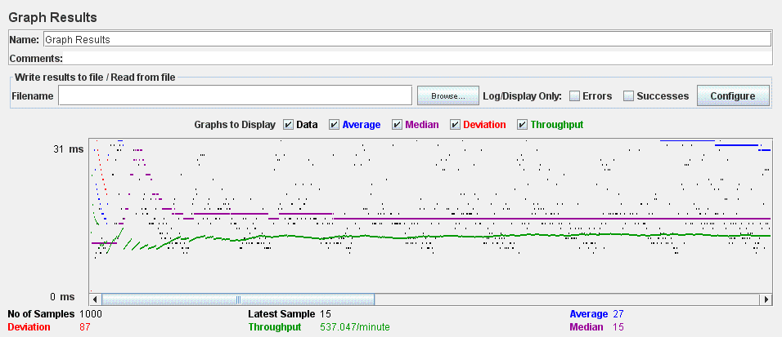

EDIT PERSONAL DATA COMPANY TEST (UC 8.2 – Acme Hacker Rank)

In this test we performance the edition of the company personal data.The test consists of 10 threads (user) doing 10 loops, these are the results.

AGGREGATE REPORT

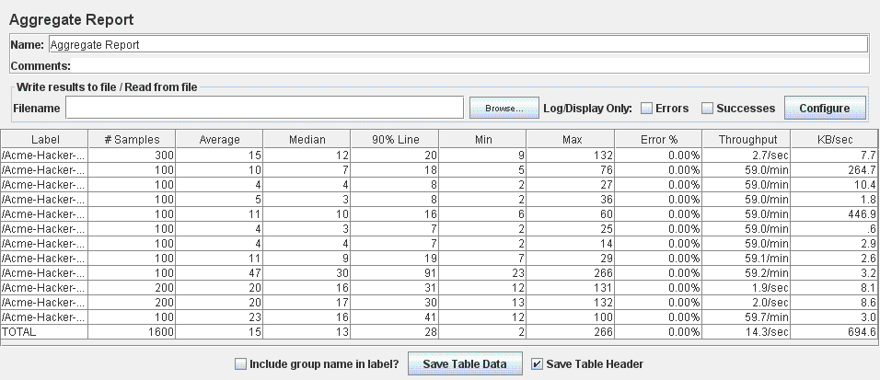

GRAPH RESULT

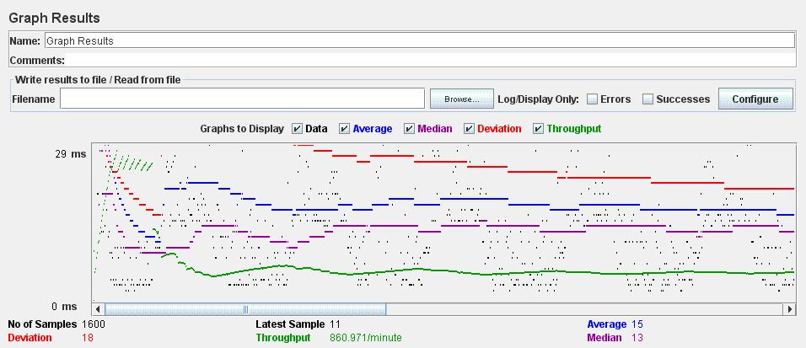

EDIT PERSONAL DATA HACKER TEST (UC 8.2 – Acme Hacker Rank)

In this test we performance the edition of the hacker personal data.The test consists of 10 threads (user) doing 10 loops, these are the results.

AGGREGATE REPORT

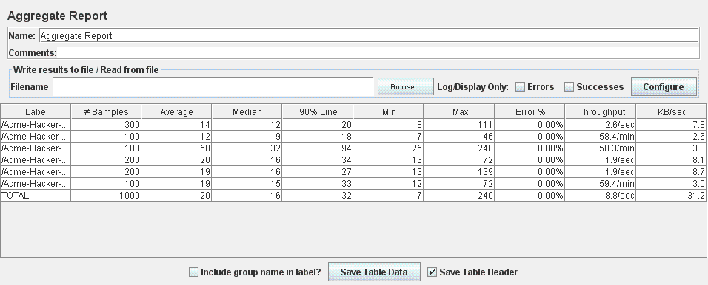

GRAPH RESULT

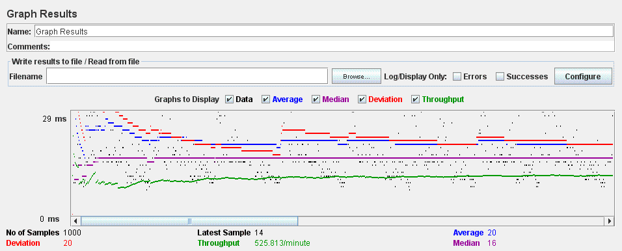

POSITION TEST (UC 9.1 – Acme Hacker Rank)

In this test we performance the creation, edit, save as draft/final, delete, cancel and show of positions. The test consists of 10 threads (user) doing 10 loops, these are the results.

AGGREGATE REPORT

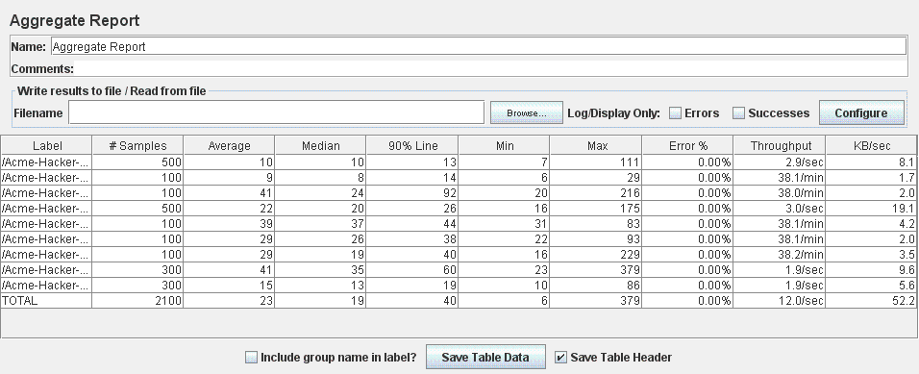

GRAPH RESULT

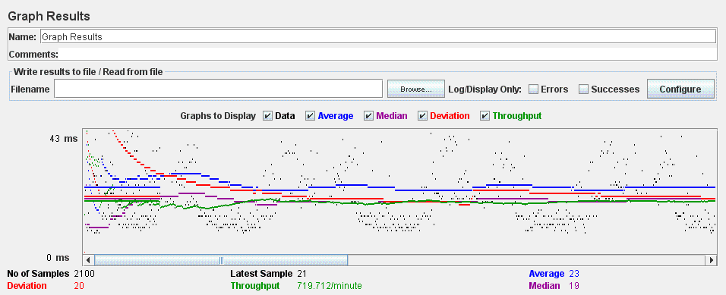

MANAGE PROBLEM TEST (UC 9.2 – Acme Hacker Rank)

In this test we performance the list, create, update, delete and show of problems. The test consists of 10 threads (user) doing 10 loops, these are the results.

AGGREGATE REPORT

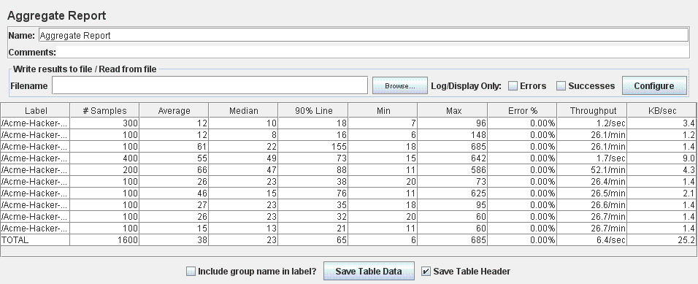

GRAPH RESULT

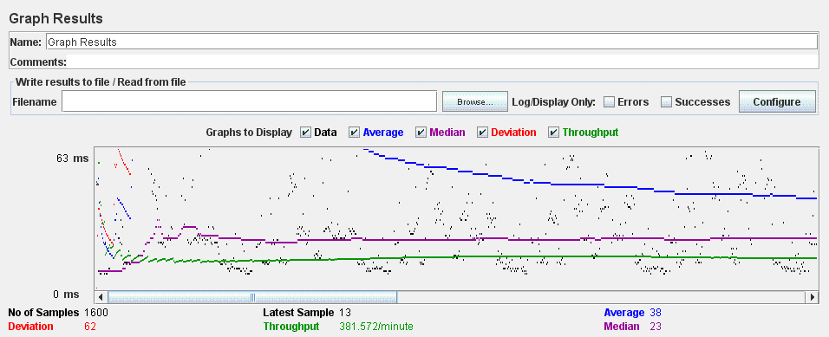

ACCEPT APLICATION TEST (UC 9.3 – Acme Hacker Rank)

In this test we performance the action of accept an application. The test consists of 10 threads (user) doing 10 loops, these are the results.

AGGREGATE REPORT

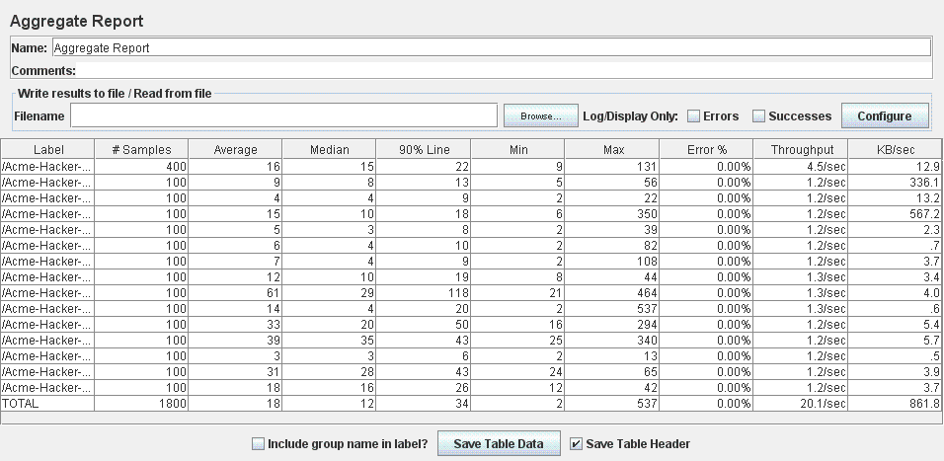

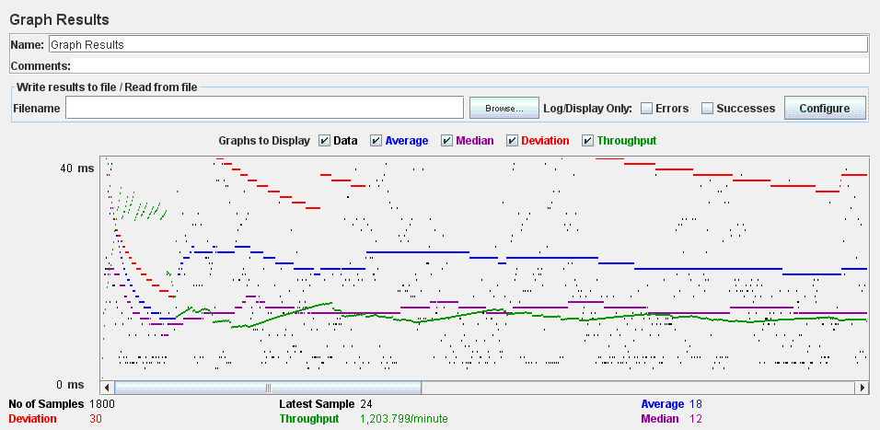GRAPH RESULT

REJECT APPLICATION TEST (UC 9.3 – Acme Hacker Rank)

In this test we performance the action of reject an application. The test consists of 10 threads (user) doing 10 loops, these are the results.

AGGREGATE REPORT

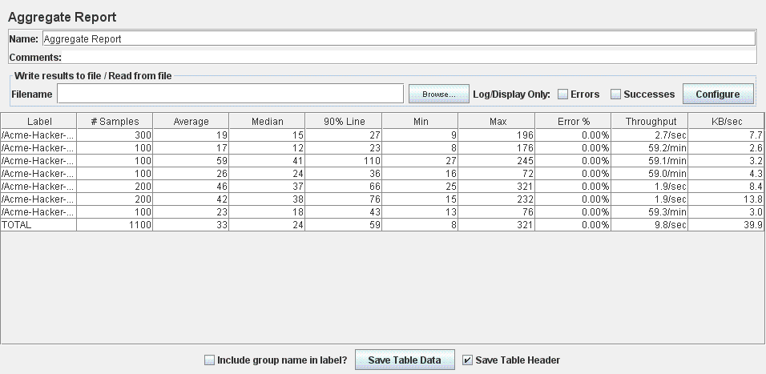

GRAPH RESULT

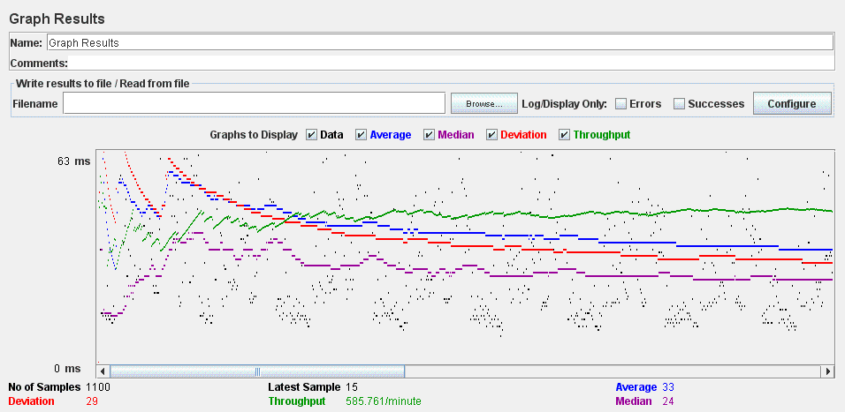

LIST, CREATE AND UPDATE APPLICATION TEST (UC 10.1 – Acme Hacker Rank)

In this test we performance the list, creation and updating applications. The test consists of 10 threads (user) doing 10 loops, these are the results.

AGGREGATE REPORT

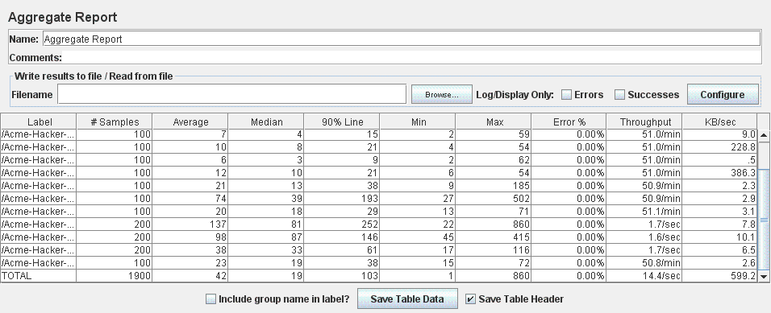

GRAPH RESULT

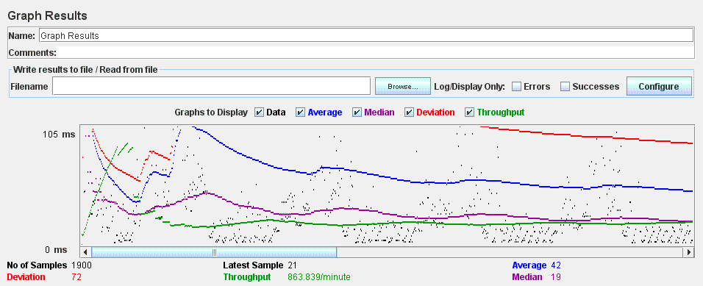

REGISTER ADMINISTRATOR TEST (UC 11.1 – Acme Hacker Rank)

In this test we performance the creation of new administrators in the system. The test consists of 10 threads (user) doing 10 loops, these are the results.

AGGREGATE REPORT

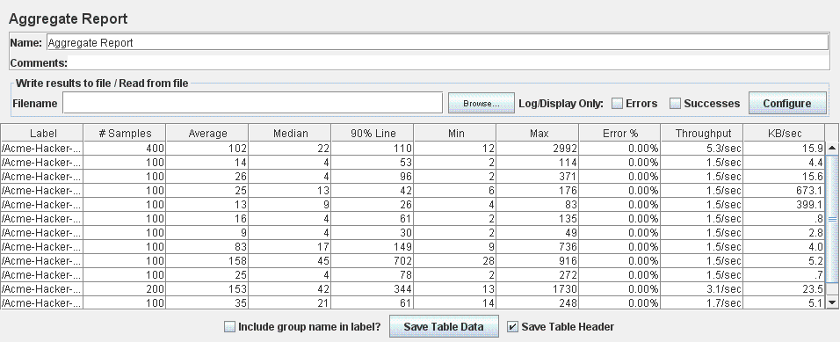

GRAPH RESULT

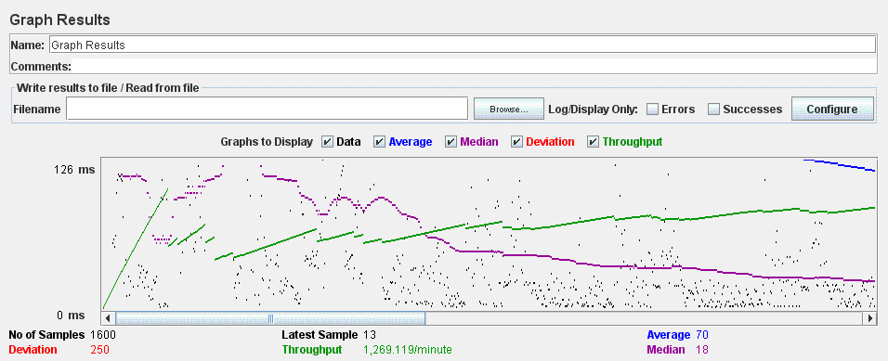

DASHBOARD TEST (UC 11.2, 18.1 – Acme Hacker Rank)

In this test we performance of the administrator dashboard. The test consists of 10 threads (user) doing 10 loops, these are the results.

AGGREGATE REPORT

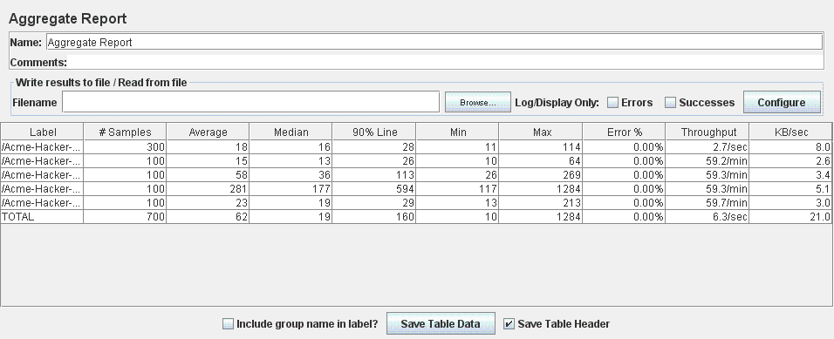

GRAPH RESULT

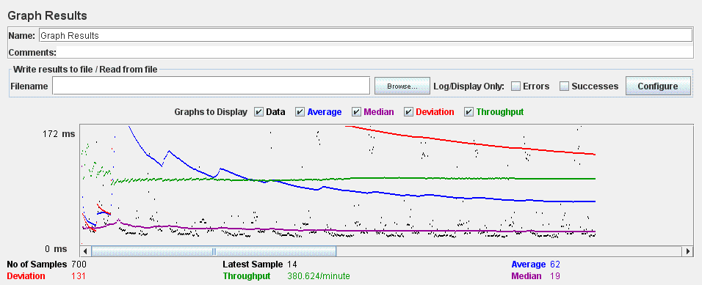

CURRICULA TEST (UC 17.1 – Acme Hacker Rank)

In this test we performance the list, create, update, show and delete of all types of curricula and their data. The test consists of 10 threads (user) doing 10 loops, these are the results.

AGGREGATE REPORT

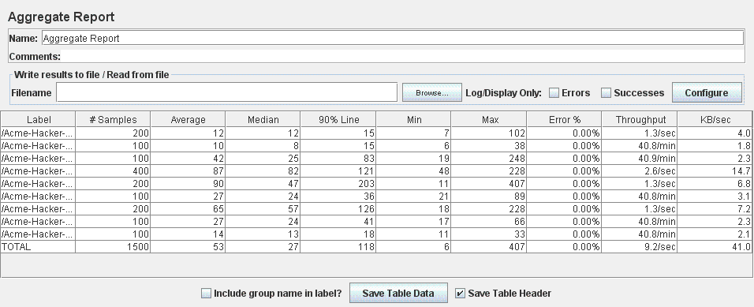

GRAPH RESULT

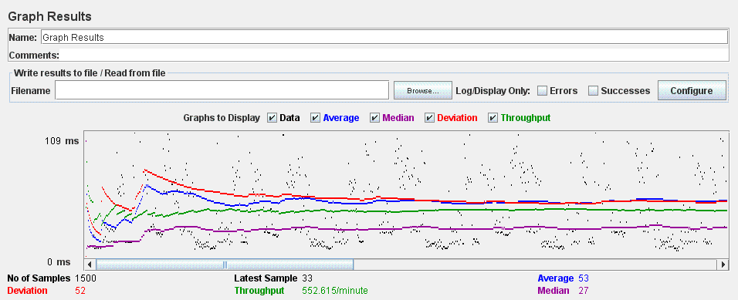

FINDER TEST (UC 17.2 – Acme Hacker Rank)

In this test we performance the search and resut list of a finder. The test consists of 10 threads (user) doing 10 loops, these are the results.

AGGREGATE REPORT

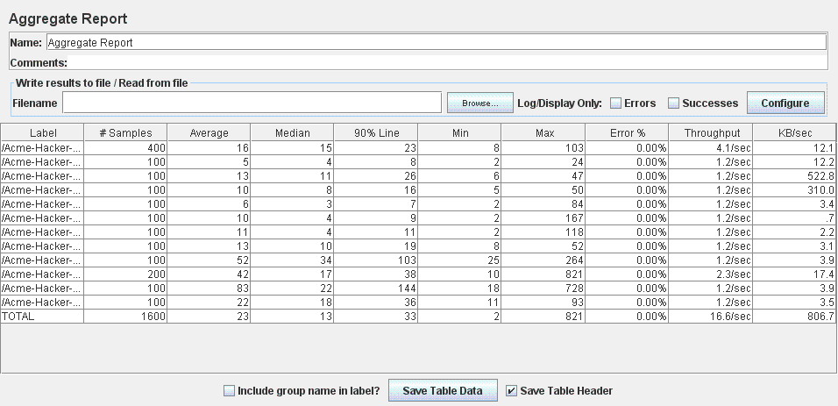

GRAPH RESULT

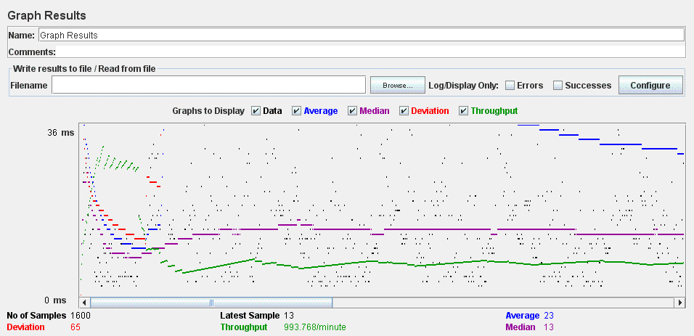

SOCIAL PROFILE TEST (UC 23.1 – Acme Hacker Rank)

In this test we performance the list, create, update, show and delete of a social profile of an actor. The test consists of 10 threads (user) doing 10 loops, these are the results.

AGGREGATE REPORT

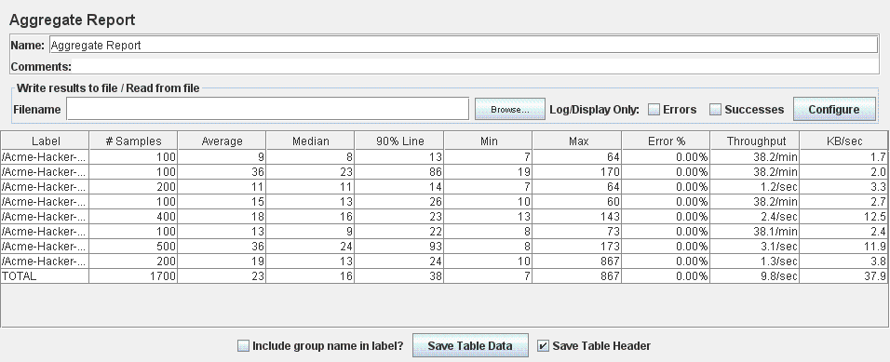

GRAPH RESULT

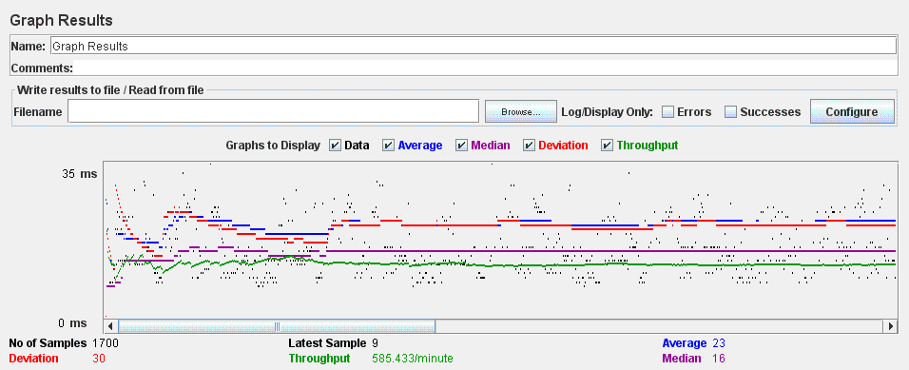

MANAGE MESSAGE TEST (UC 23.2 – Acme Hacker Rank)

In this test we performance the list, creation, show and delete of messages. The test consists of 10 threads (user) doing 10 loops, these are the results.

AGGREGATE REPORT

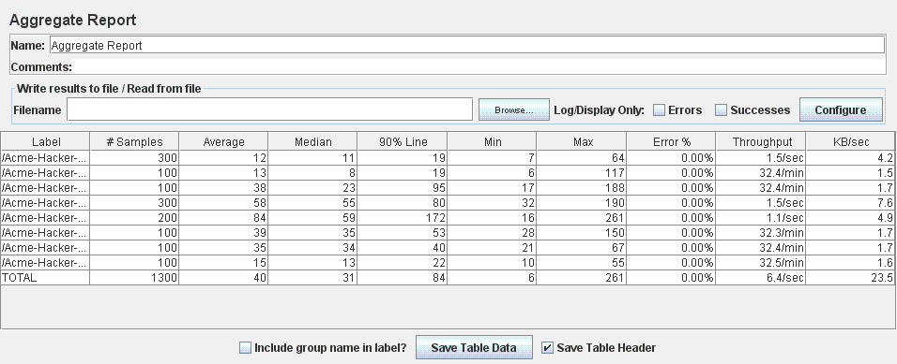

GRAPH RESULT

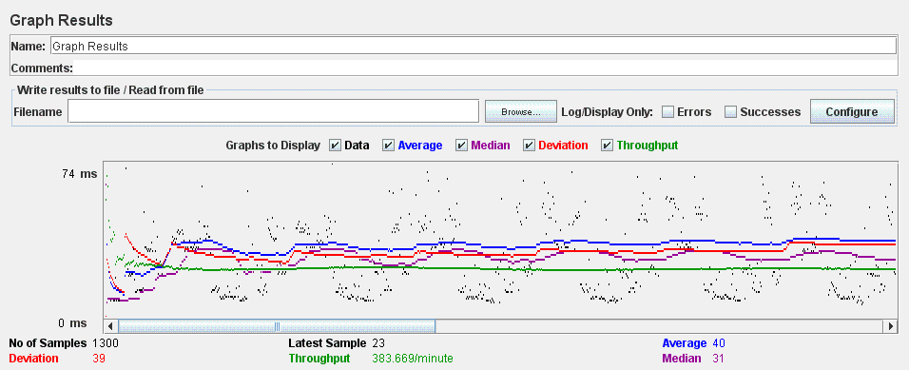

BROADCAST TEST (UC 24.1 – Acme Hacker Rank)

In this test we performance the broadcast of a message by an administrator. The test consists of 10 threads (user) doing 10 loops, these are the results.

AGGREGATE REPORT

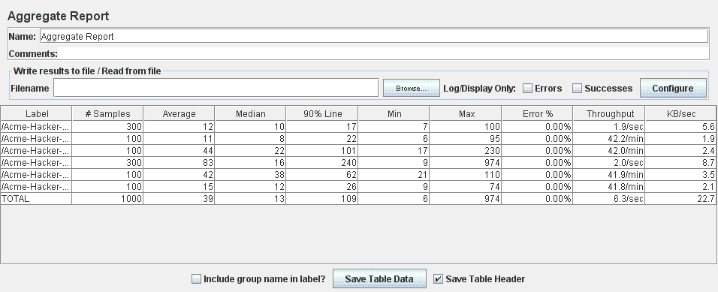

GRAPH RESULT

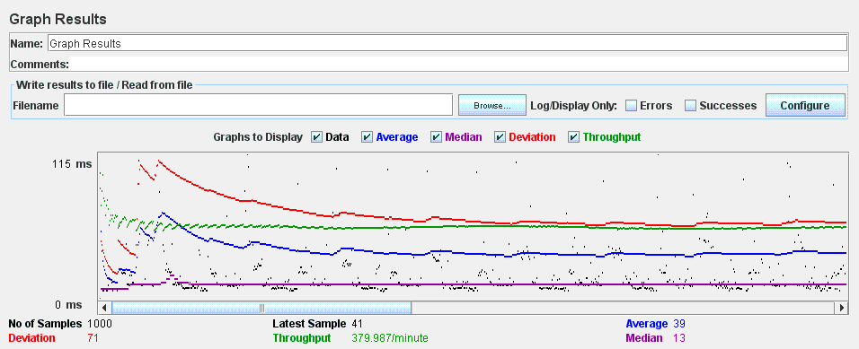

SPAM, BAN AND UNBAN TEST (UC 24.2, 24.3, 24.4 – Acme Hacker Rank)

In this test we performance the process to calculate spammers, ban and unban users. The test consists of 10 threads (user) doing 10 loops, these are the results.

AGGREGATE REPORT

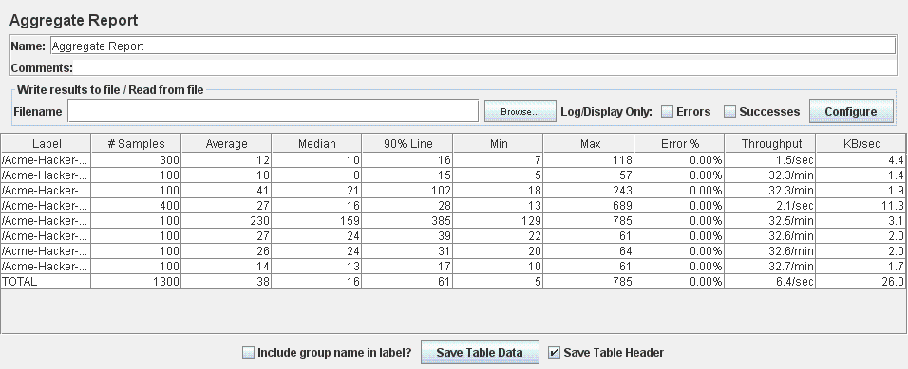

GRAPH RESULT

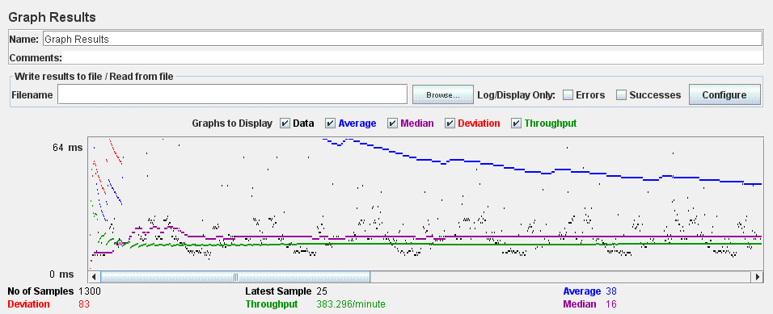

MANAGE AUDIT TEST (UC 3.1 – Acme Rookies)

In this test we performance the list, create, update, delete and show of audit by an auditor. The test consists of 10 threads (user) doing 10 loops, these are the results.

AGGREGATE REPORT

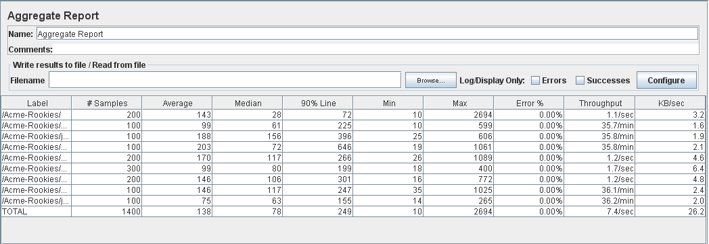

GRAPH RESULT

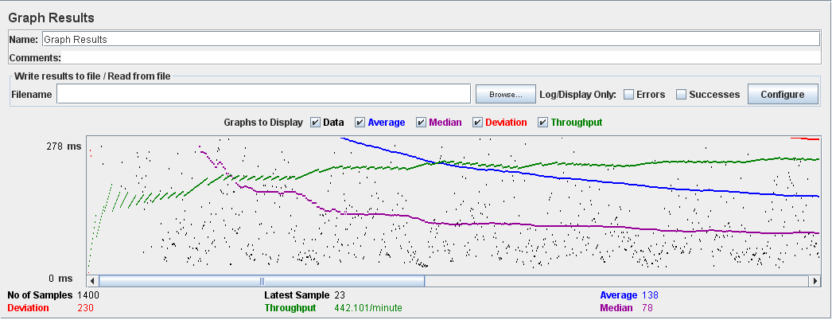

REBRANDING SYSTEM TEST (UC 4.1 – Acme Rookies)

In this test we performance run a procedure to notify the existing users of the rebranding. The test consists of 10 threads (user) doing 10 loops, these are the results.

AGGREGATE REPORT

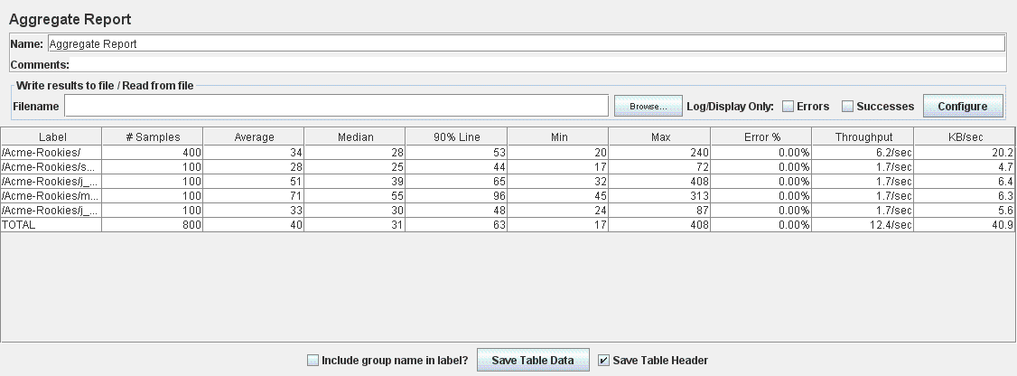

GRAPH RESULT

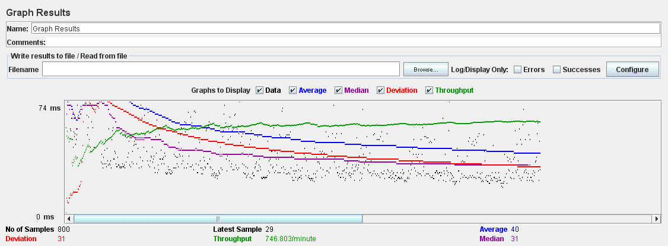

REGISTER AUDITOR TEST (UC 4.2 – Acme Rookies)

In this test we performance register a new auditor. The test consists of 10 threads (user) doing 10 loops, these are the results.

AGGREGATE REPORT

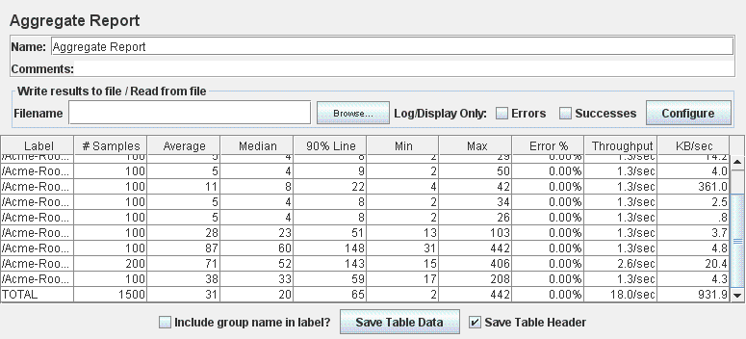

GRAPH RESULT

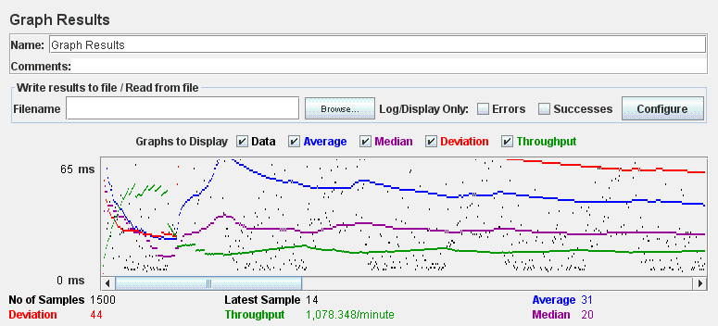

COMPUTER AUDIT TEST (UC 4.3 – Acme Rookies)

In this test we performance launch a process to compute an audit score for every company. The test consists of 10 threads (user) doing 10 loops, these are the results.

AGGREGATE REPORT

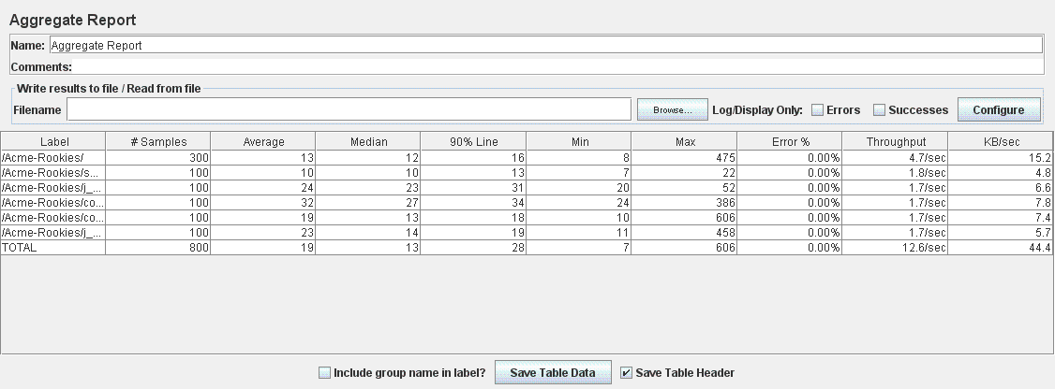

GRAPH RESULT

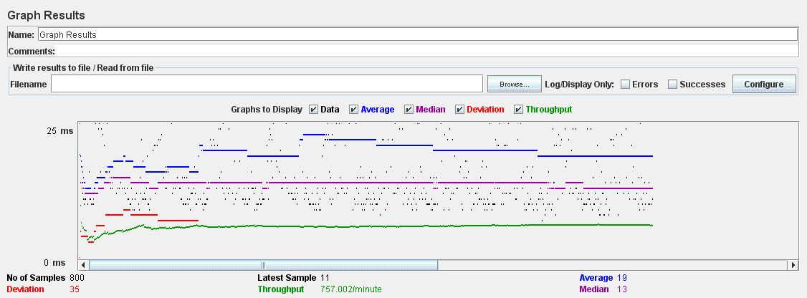

DASHBOARD TEST (UC 4.4, UC 11.1, UC 14.1 – Acme Rookies)

In this test we performance of the administrator dashboard. The test consists of 10 threads (user) doing 10 loops, these are the results.

AGGREGATE REPORT

‘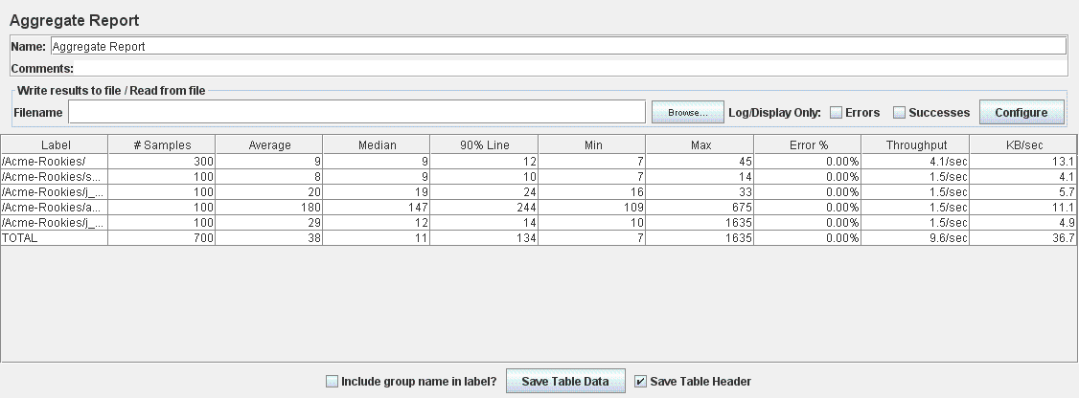

GRAPH RESULT

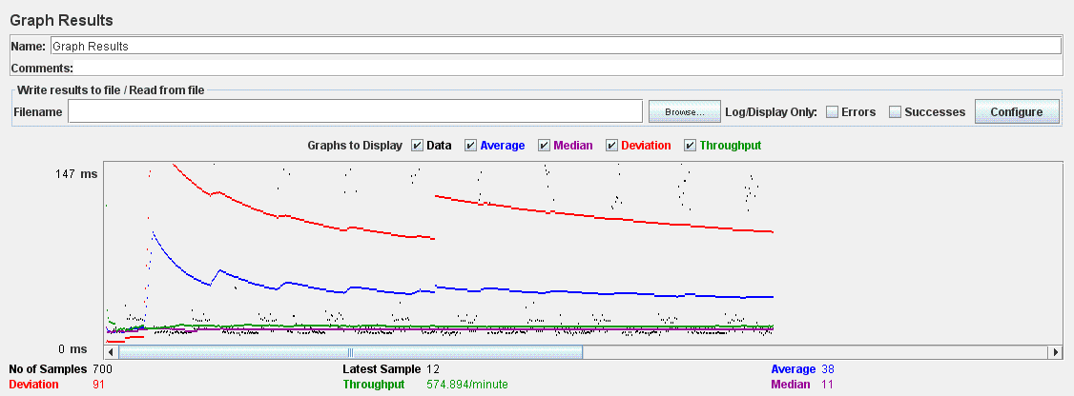

LIST PROVIDER TEST (UC 9.1– Acme Rookies)

In this test we performance browse the list of providers and navigate to their items. The test consists of 10 threads (user) doing 10 loops, these are the results.

AGGREGATE REPORT

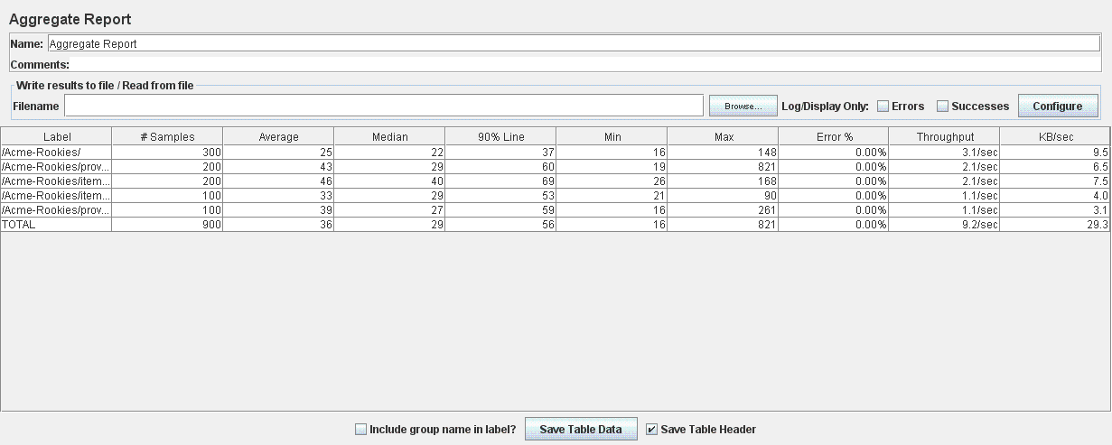

GRAPH RESULT

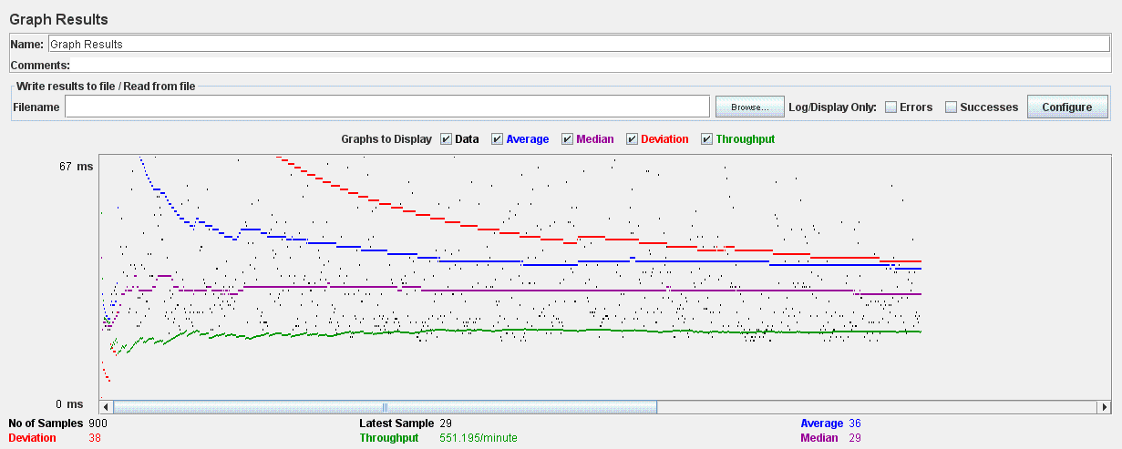

LIST ITEM TEST (UC 9.2– Acme Rookies)

In this test we performance browse the list of items and navigate to their providers. The test consists of 10 threads (user) doing 10 loops, these are the results.

AGGREGATE REPORT

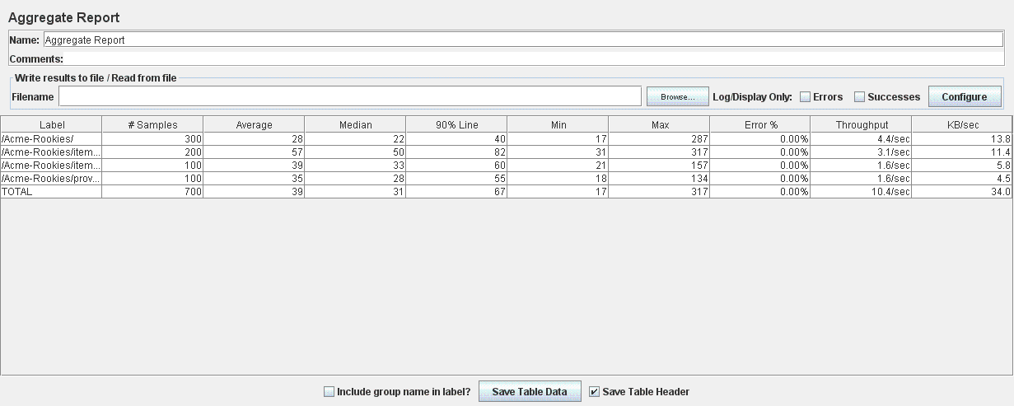

GRAPH RESULT

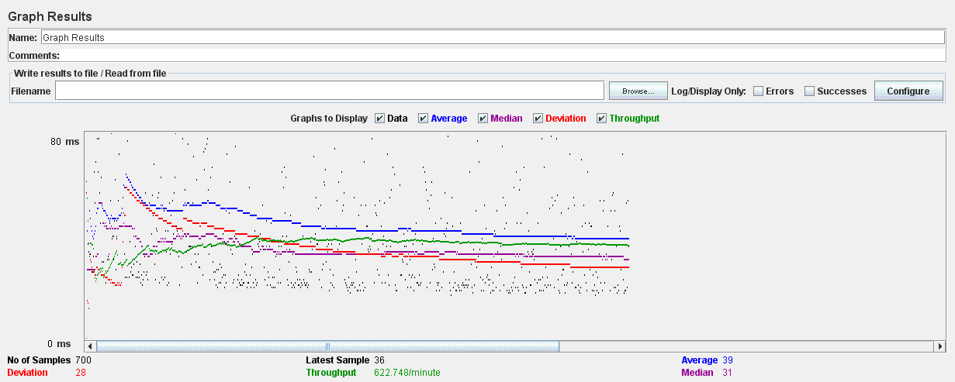

REGISTER PROVIDER TEST (UC 9.3– Acme Rookies)

In this test we performance register a new provider. The test consists of 10 threads (user) doing 10 loops, these are the results.

AGGREGATE REPORT

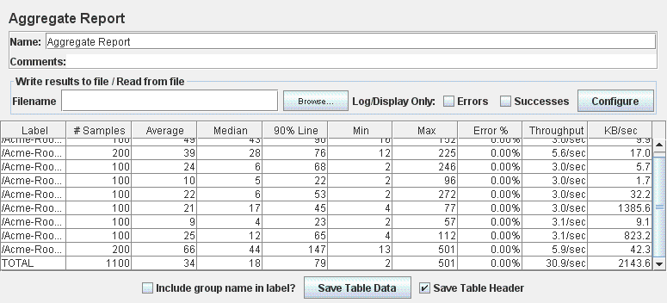

GRAPH RESULT

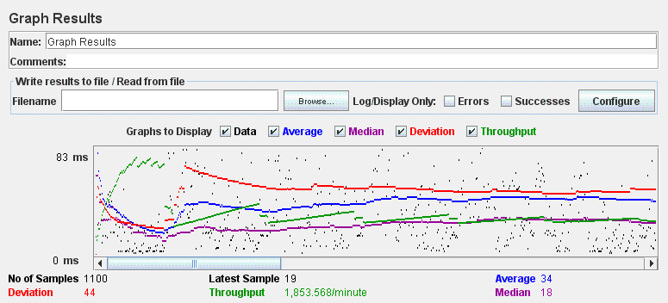

MANAGE ITEM TEST (UC 10.1 – Acme Rookies)

In this test we performance the list, create, update, delete and show of items. The test consists of 10 threads (user) doing 10 loops, these are the results.

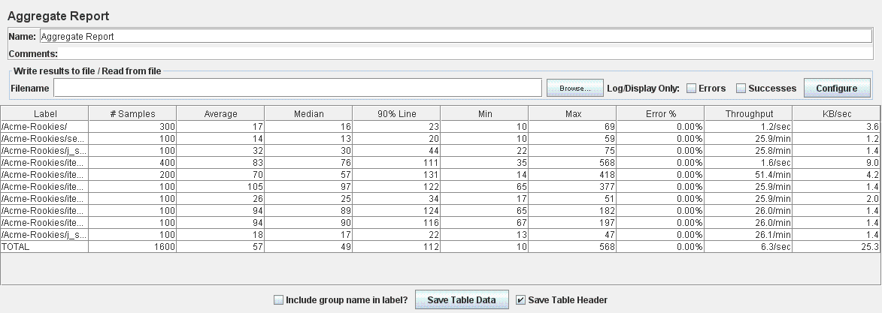AGGREGATE REPORT

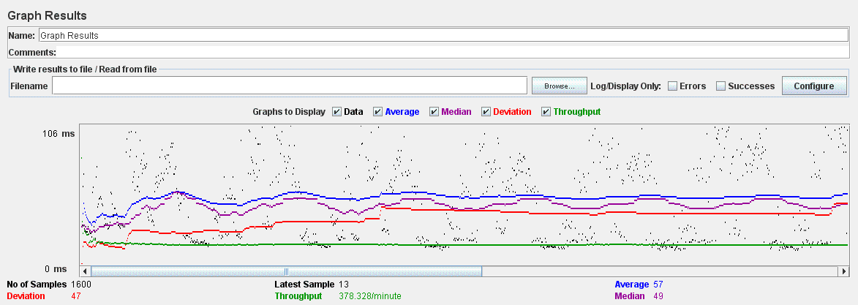GRAPH RESULT

MANAGE SPONSORSHIPS TEST (UC 13.1 – Acme Rookies)

In this test we performance the list, create, update, delete and show of sponsorships. The test consists of 10 threads (user) doing 10 loops, these are the results.

AGGREGATE REPORT

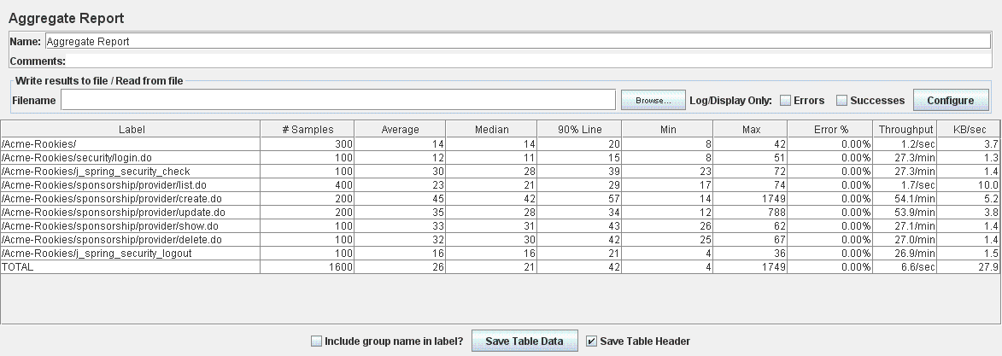

GRAPH RESULT

